Name: Zainab Azeem

Roll No: 21P-8025

Program: BCS

Assignment 2

Question No 1:

CODE

n=int(input("enter no of cookies:")) #input from user

box=int(input("enter no of cookies in box:"))

container=int(input("enter no of cookie boxes in container:"))

a=n//box #cookies in a box

b=n%box

x=a//container #no of boxes container con hold

y=a%container

print(a,'boxes')

print(b,"leftover cookies")

print(x,"container")

print(y,"leftover boxes")

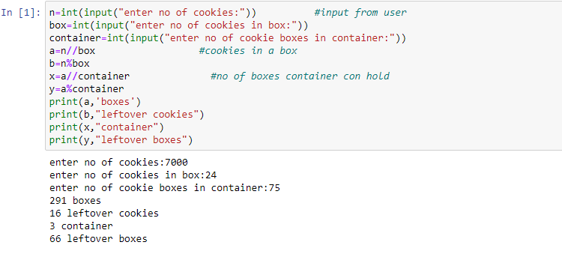

QUESTION NO 2:

CODE

def fac(n): #def function factorial

i=1

fac=1

while i<=n:

fac=fac*i

i+=1

return fac

n=int(input("enter number")) #user input

x=int(input("enter number"))

k=0 #initializing values

y=0

for k in range(k,n+1): #range for summition of series

a=pow(x,k)

b=fac(k)

sum=a/b

y+=sum

print(round(y,1))

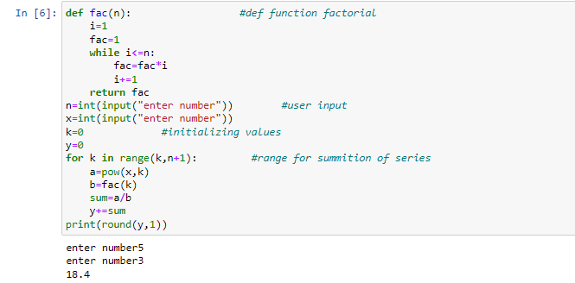

Question no 3:

n=int(input("enter number:")) #user input

for i in range(n+1): #loops for upper haif of diamond

print(" ")

for j in range(n-i):

print(" ",end=" ")

for j in range(i+1):

print(" ",i,end=" ")

for i in range(n-1,-1,-1): #loops of lower half of diamond

print(" ")

for j in range(n-i):

print(" ",end=" ")

for j in range(i,-1,-1):

print(" ",i,end=" ")

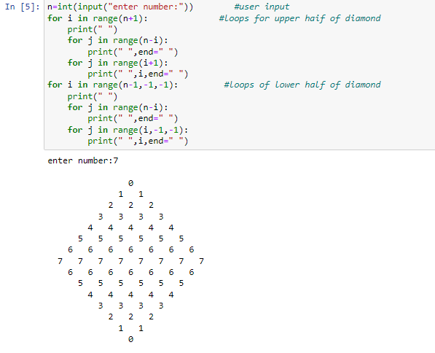

QUESTION NO: 4

for num in range(1,10000): #Finding first 4 perfect numbers

sum=0

for i in range(1,num):

if num%i==0: #number divide by range form i to num

sum+=i

if sum==num: #if sum is equal to number than it is perfect number

print(num,"is a perfect number")

for i in range(1,sum):

a=sum%i

if a==0:

print(i,"+",end="") #print the numbers which sum is equal to perfect no

print(" =",sum)

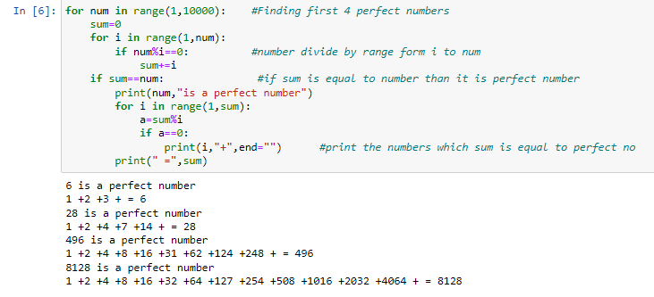

Question no 5

column1=0 #intilize values

row2=1

while column1!=row2:

row1=int(input("enter rows of matrix 1:")) #user inputs

column1=int(input("enter column of matrix 1:"))

row2=int(input("enter rows of matrix 2:"))

column2=int(input("enter column 0f matrix 2:"))

if column1!=row2:

print("Error! column of first matrix not equal to row of second matrix")

# in matrice multiplication column of matrice1 equal to rows of matrice2

print("-------------------------------------------->")

print("Elements of matrix1")

matrix1=[[int(input("enter element of matrix 1:")) for i in range(column1)] for j in range(row1)]

#no of elements in matrix1

print("-------------------------------------------->")

matrix2=[[int(input("enter element of matrix 2:")) for i in range(column2)] for j in range(row2)]

#no of elements in matrix2

print("-------------------------------------------->")

result=[[0 for i in range(row1)] for j in range(column2)]

#third matrix for result

for i in range(row1):

for j in range(column2):

for k in range(row2):

result[i][j]+=matrix1[i][k] * matrix2[k][j]

print("Output Matrix")

for i in range(row1):

for j in range(column2):

print(format(result[i][j],"<8"),end="")

print()

